U.S. Food and Drug Administration
Pacific Retail Food Seminar

September 10 - 12, 2019

Sheraton Mesa Hotel at Wrigleyville West
860 N. Riverview, Mesa, AZ 85201

SEMINAR AGENDA

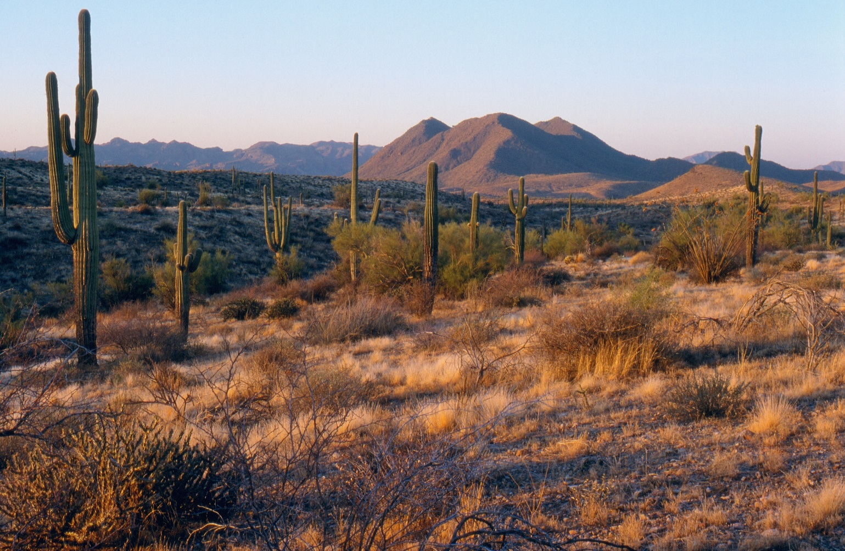

FDA Pacific Retail Food Seminar Agenda
Tuesday, SEPTEMBER 10, 2019
7:30 AM | Registration
Moderator – Bianca Arriaga
8:30 AM | Welcome from Maricopa County, AZ | Darcy Kober, Maricopa County Environmental Services Department
8:45 AM | FDA Welcome & Office of State Cooperative Programs Report | Christopher Smith, U. S. Food and Drug Administration
9:15 AM | Denver District Office Report | Mark Harris, U. S. Food and Drug Administration
9:30 AM | CFSAN Report | CDR Jessica Otto, U. S. Food and Drug Administration
10:15 AM | Break
10:30 AM | Office of Training, Education and Development Report | Kim Destromp, U. S. Food and Drug Administration
11:15 AM | USDA/FSIS Retail Update | Kristina Barlow, USDA, FSIS
11:45 AM | Lunch – Provided
Moderator – Mario Seminara
1:00 PM | Alaska State Report | Ytamar Rodriguez, Alaska Department of Environmental Conservation
1:15 PM | Returnable Containers | Panel: Jodi Callister, WinCo and Joe Graham, WA; Christina Springer, Oregon Department of Agriculture
2:15 PM | Break
2:30 PM | Arizona State Report | Bianca Arriaga, Arizona Department of Health Services,
2:45 PM | FDA Role in Regulation of Cannabis Products | Sharon Lindan Mayl, U.S. Food and Drug Administration
3:45 PM | Public Health Codes: Regulation and Inspection of Marijuana Businesses | Panel: Angelique Finney, Washington State Department of Agriculture; Susan Kendrick, Oregon Department of Agriculture; Joseph Roller, NV; Industry: Thuy Vu, Hammer Enterprises, CO
5:00 PM | Adjourn

FDA-Pacific Retail Food Seminar Agenda
Wednesday, SEPTEMBER 11, 2019
7:30 AM | Registration

Moderator – Katey Kennedy
8:00 AM | Fermenting at Retail Part 1 | Natalie Seymour, NC State University
9:00 AM | Retail Program Standards Funding Opportunities and the Future | Barbara Kitay, U.S. Food and Drug Administration
9:45 AM | Hawaii State Report | Peter Oshiro, Department of Health – Sanitation Branch/Food Services, HI
10:00 AM | Break
10:15 AM | AFDO-Managed Retail Program Standards  Grant Program | Michael Turner, Association of Food and Drug Officials (AFDO)
10:30 AM | Lime juice doesn't cook fish, you should be vaccinated against hepatitis A, and other things I've learned along the way: A tale of a(nother) Hepatitis A outbreak | Mackenzie Tewell, Arizona Department of Health Services
11:30 AM | Idaho State Report | Mathew Walker, ID Department of Health and Welfare
11:45 PM | Lunch – Provided
Moderator – Rich Ramirez
1:00 PM | US Military Report | Sonia Beare, Madigan Army Medical Center, Joint Base Lewis-McChord, Tacoma, WA
1:15 PM | Fermenting at Retail Part 2 | Natalie Seymour, NC State University
2:15 PM | Montana State Report | Jeff Havens, State of Montana, Department of Public Health and Human Services
2:30 PM | Break
2:45 PM | Entomophagy, Science of Eating Insects | Professor Goggy Davidowitz, University of Arizona
4:00 PM | Nevada State Report | Lindsey M. Doolittle, Nevada Department of Health and Human Services
4:15 PM | Inspection Protocols for a Cannabis Operation | Thuy Vu, Hammer Enterprises
5:00 PM | Adjourn

FDA- Pacific retail food Seminar agenda
Thursday, SEPTEMBER 12, 2019
Moderator –David Engelskirchen
7:15 AM | Breakfast Provided
8:00 AM | Live Molluscan Shellfish Tanks | Kristina Phelps, U.S. Food and Drug Administration
9:00 AM | Oregon Department of Health Report | David Martin, Oregon Health Authority
9:15 AM | Oregon Department of Agriculture Report | John Burr, Oregon Department of Agriculture
9:30 AM | Break
9:45 AM | Washington State Report | Joseph M. Graham, Washington Department of Health
10:00 AM | Flexible Funding Model Facilitated Discussion | John Marcello, U. S. Food and Drug Administration
11:00 AM | Guam Report/Pest Infestation Threshold Determination Plan | Katherine Del Mundo, Guam Department of Public Health and Social Services
11:30 AM | Indian Health Service | CDR Sarah-Jean Snyder, Indian Health Service
11:45 PM | Closing Remarks | Christopher Smith, U.S. Food and Drug Administration
12:00 PM | Adjourn
Moderator – Brad Tufto
12:30 PM | State Food Program Managers Meeting
2:00 PM | Adjourn

